Hadoop Developer – Sqoop Case Study
Hadoop Developer Training-
Sqoop Case study
- Create a table named employee_personal in mysql with below schema.

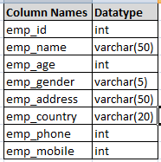

- Create a new table named employee_official in mysql with below schema.

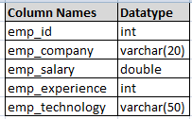
Note: emp_id in this table can be used as foreign key

- Insert below data to employee_personal table.

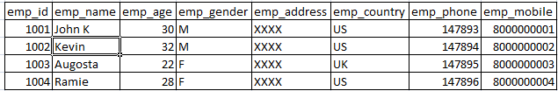

- Insert below data to employee_official table

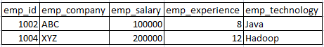

- Import data of employee_personal table into HDFS path /employee/personal using 3 mappers.

- Validate the content of imported data in HDFS. It should be same as in employee_personal table.

- Import the names of all employees along with their company name and salary who are greater than 25 years of age.

- Import the data from employee_official table of RDBMS to Hive table.

- Insert one more row to rdbms table employee_personal

- Import only newly added row to HDFS directory /employee/personal . (Hint- Incremental import)

- Create a new table in mysql as replica of employee_personal and name it as employee_replica with below schema.

- Export the data from HDFS path /employee/personal to newly created table employee_replica.


About Capgemini
With almost 145,000 people in over 40 countries, Capgemini is one of the world's foremost providers of consulting, technology and outsourcing services. The Group reported 2014 global revenues of EUR 10.573 billion.
Together with its clients, Capgemini creates and delivers business and technology solutions that fit their needs and drive the results they want. A deeply multicultural organization, Capgemini has developed its own way of working, the Collaborative Business Experience™, and draws on Rightshore®, its worldwide delivery model

 | Name Name  Function  Function  Phone:00 00 00 00 00  email@capgemini.com
Name Name
Function
Function
Phone:00 00 00 00 00
email@capgemini.com
Name Name
Function
Function
Phone:00 00 00 00 00
email@capgemini.com
Name Name
Function
Function
Phone:00 00 00 00 00
email@capgemini.com
www.capgemini.com

The information contained in this document is proprietary and confidential.
It is for Capgemini internal use only. Copyright © 2015 Capgemini. All rights reserved.
Rightshore® is a trademark belonging to Capgemini.

